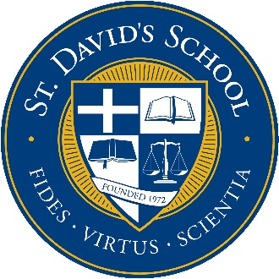

St. David's School
community service form

Thank you for allowing our student the opportunity to volunteer with your agency. Since community service is part of our students’ high school transcripts, we need your help in documenting our students’ community service with your agency. Your assistance in providing the following information would be appreciated.

If you have any questions, please feel free to contact me at 919-782-3331.

Sincerely,

Scott Shaw
Upper School Principal

Name of student volunteer:

Graduation year:

Name and address of agency:

Date of volunteer service:

Total hours of service:

Please provide a brief description of volunteer duties and services performed:

Signature of Supervising Agency Representative

Official title Date

3400 White Oak Road • Raleigh, NC 27609 • Phone 919-782-3331 • FAX 919-787-9417 • www.sdsw.org

